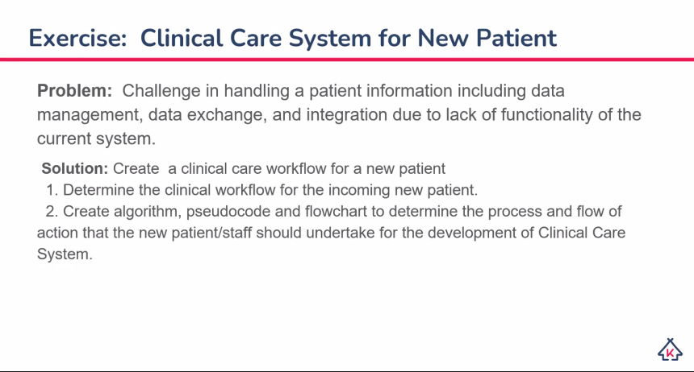

Clinical Care Workflow for a new patient

Pseudocode

* Every action required of the patient in this pseudocode may be fulfilled by his/her aide.

1. Start: New patient arrives at the hospital
2. Security checks for Arrival Status (Dead on Arrival or not)
3. Security provides the patient and fills up the arrival status
4. Security checks for hazardous items
5. If patient has hazardous items,

follow “Put items on hold” workflow

1. Admit to hospital premises
2. Nurse receives patient and completes the Patient Data Sheet which would contain
   1. Initial Physiological Analysis such as BP, Height, and Weight
   2. Personal Information such as Name, Date of Birth and contact information
   3. Reason for visit
3. If all doctors are unavailable,

the nurse provides the patient the queue number in accordance with the Reason for visit

1. Nurse forwards the patient to the Healthcare department in accordance with the Reason for visit (Each department would have a separate workflow)
2. The Healthcare department would include in its workflow updating the Patient Data Sheet
3. The Patient will be escorted out of the premises
4. End: The patient leaves the hospital

Algorithm

1. Display ‘Welcome new Patient.’
2. Initialize obj_patient
3. Input obj_patient.status
4. if (hazard in obj_patient), proceed to put_on_hold workflow
5. Input:
   1. Height
   2. Weight
   3. Blood Pressure
   4. Name
   5. Date of Birth
   6. Contact Number
   7. Email
   8. Reason for visit
6. If (doctors<1), set obj_patient.queue + 1
7. If (doctors>=1), assign obj_patient to doctor[0]
8. obj_patient will follow the health care workflow
9. set obj_patient.procedures_made
10. save obj_patient